ELEG 312 - Example Problems Chapter 10-4

**Example 10.12**

Consider an active-loaded MOS differential amplifier of the type shown in Fig. 10.37(a). Assume that for all transistors, *W*/*L* = 7.2 µm/0.36 µm, *Cgs* = 20 fF, *Cgd* = 5 fF, and *Cdb* = 5 fF. Also, let *µnCox* = 387 µA/V2, *µpCox* = 86 µA/V2, *V’An* = 5 V/m, |*V’Ap*| =6 V/m. The bias current *I* = 0.2 mA, and the bias current source has an output resistance *RSS* = 25 k and an output capacitance *CSS* = 0.2 pF. In addition to the capacitances introduced by the transistors at the output node, there is a capacitance *Cx* of 25 fF. It is required to determine the low-frequency values of *Ad*, *Acm*, and CMRR. It is also required to find the poles and zero of *Ad* and the dominant pole of CMRR.

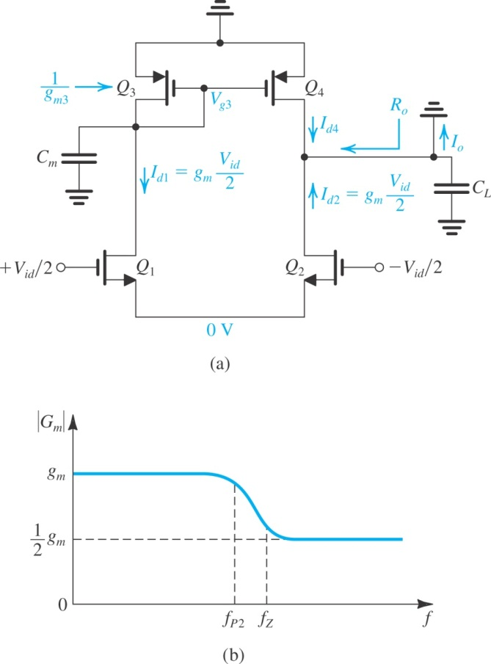

**Example 10.13**

Consider a CC–CE amplifier such as that in Fig. 10.39(b) with the following specifications: *I*1 = *I*2 = 1 mA and identical transistors with *β* = 100, *fT* = 400 MHz, and *Cμ* = 2 pF. Let the amplifier be fed with a source *V*sig having a resistance *R*sig = 4 kW, and assume a load resistance of 4 kW. Find the voltage gain *AM*, and estimate the 3-dB frequency, *fH*. Compare the results with those obtained with a CE amplifier operating under the same conditions. For simplicity, neglect *ro* and *rx*.

